

Mohsin ALI

SU92-BSDSM-F24-028

AI Story Generator

(Flask + NLP + Generative AI API)

Project Overview
The AI Story Generator is a web-based application that generates creative and engaging stories based on user input prompts using Artificial Intelligence (NLP + Generative AI API).
The system processes user ideas and converts them into well-structured stories through an AI model integrated into a Flask backend.

Features
- AI-powered story generation from user prompts
- Natural Language Processing (NLP) for text understanding
- Flask-based web application
- Simple, clean, and responsive user interface
- Fast API response for story generation
- Mobile-friendly design
- Multiple story outputs from a single prompt (optional)

- Frontend: HTML, CSS, JavaScript
- Backend: Python (Flask)
- AI/NLP: OpenAI / Gemini API (or any generative AI model)
- Libraries Used:
  - Flask
  - requests
  - nltk / spaCy (if used)
  - python-dotenv
Structure:
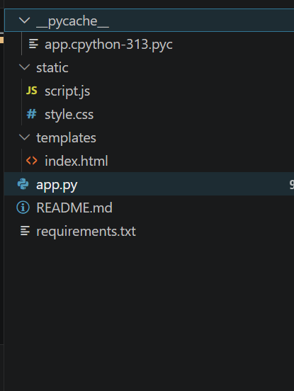

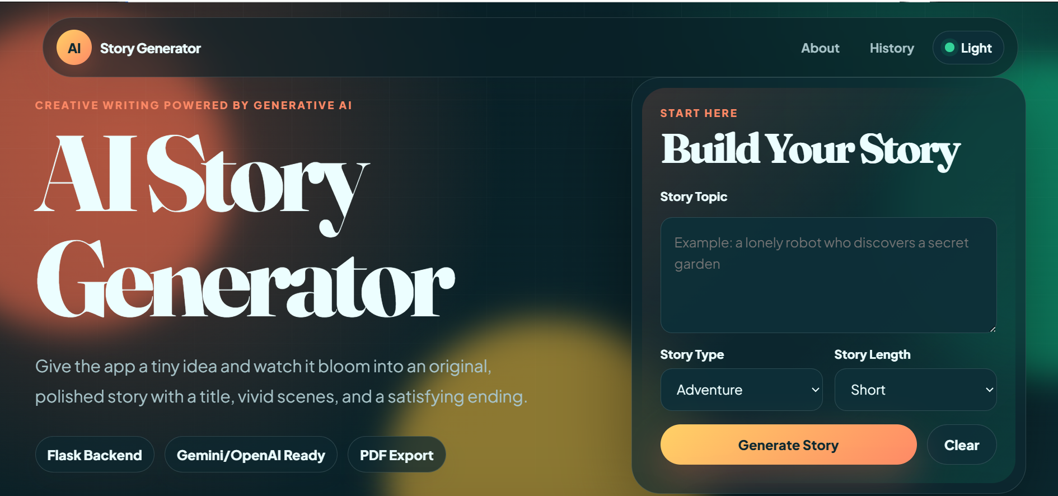
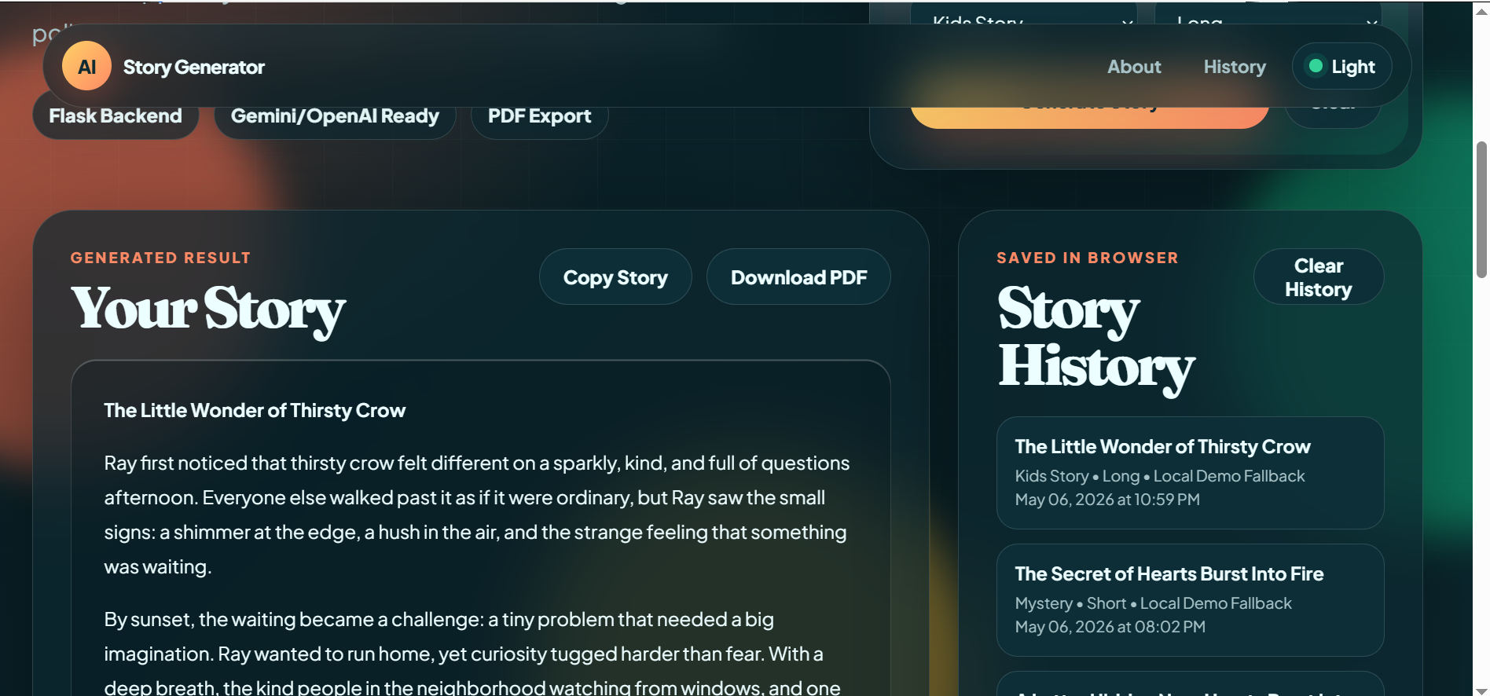
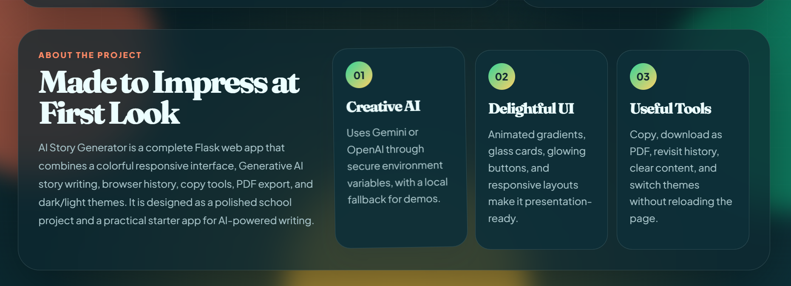

How It Works
- User enters a story prompt
- Flask backend receives the request
- Prompt is processed (optional NLP step)
- AI API generates a story
- Generated story is returned to frontend
- User sees the final story on screen

Future Improvements
- Voice input for story generation
- Download story as PDF
- Save favorite stories
- Story categories (horror, romance, sci-fi)
- User login system
- Multi-language support
Github repo link:
\https://github.com/mohsinjutt-313/PAI-Lab/blob/main/PAI%20lab%20project%20(ai%20story%20).zip

